**Steps to Create and Transform a Dataset in Power BI**

**Step 1: Open Power BI**

* + Launch the Power BI Desktop application on your system.

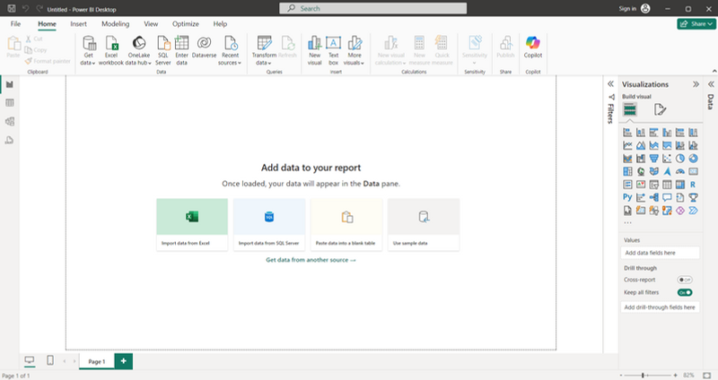

**Step 2: Import the Dataset**

* + **Click on "Get Data":** When you click on **Get Data**, a menu will appear. From the options, select **Text/CSV** and choose your dataset.

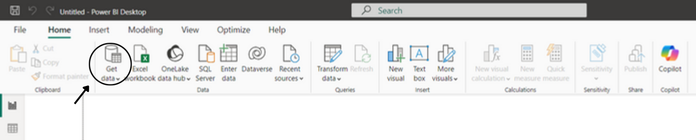

* + **Load the Dataset:** After selecting the file, a dialog box will appear with options like **Load**, **Transform**, or **Cancel**. Click on **Load** to add the dataset.

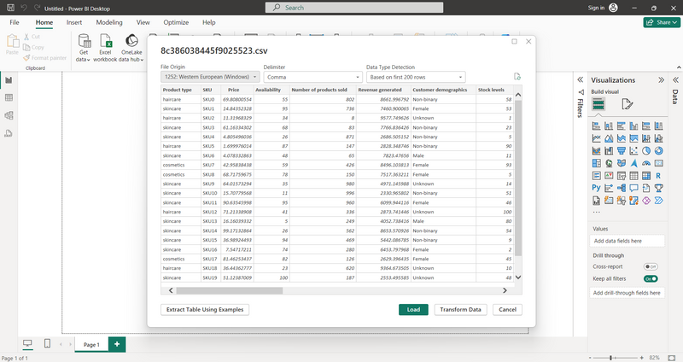

**Step 3: Transform the Dataset**

**Click "Transform Data":**

* Go to the **Home tab** and click on the **Transform Data** button. The **Power Query Editor** window will open.

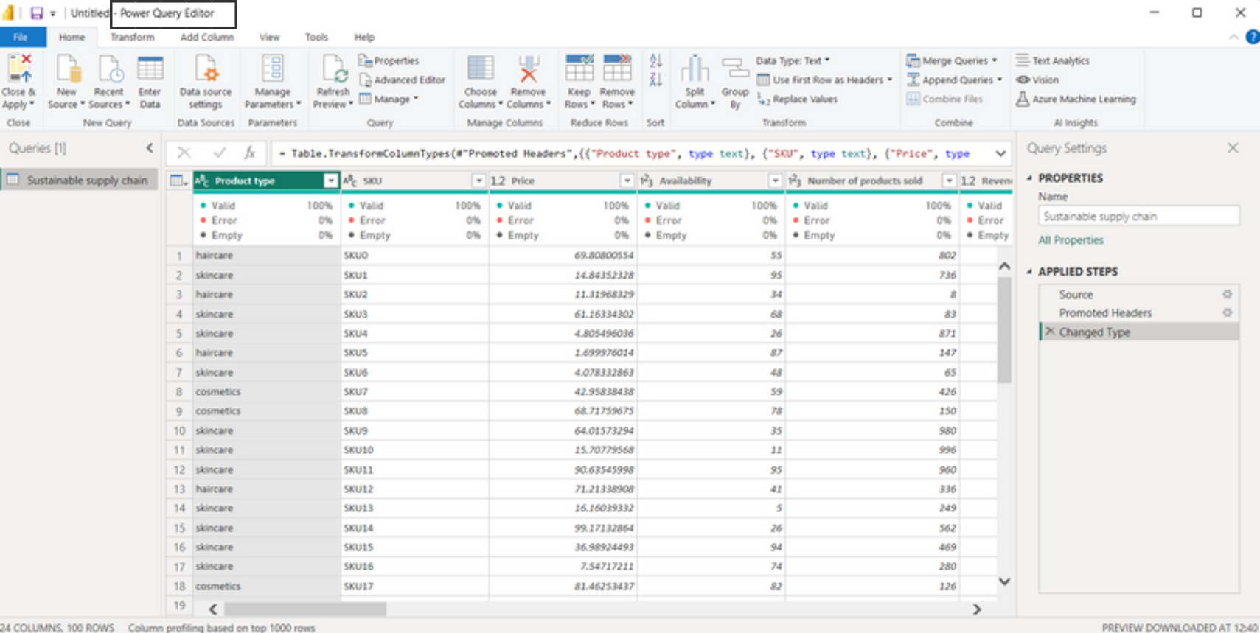

**Duplicate the Dataset:**

* On the **left-hand side**, locate your dataset in the Queries pane.
* Right-click on the dataset name and select **Duplicate**.

**Rename the Dataset :**

* Right-click on the duplicated dataset and select **Rename**.
* Enter the new name for the dataset.

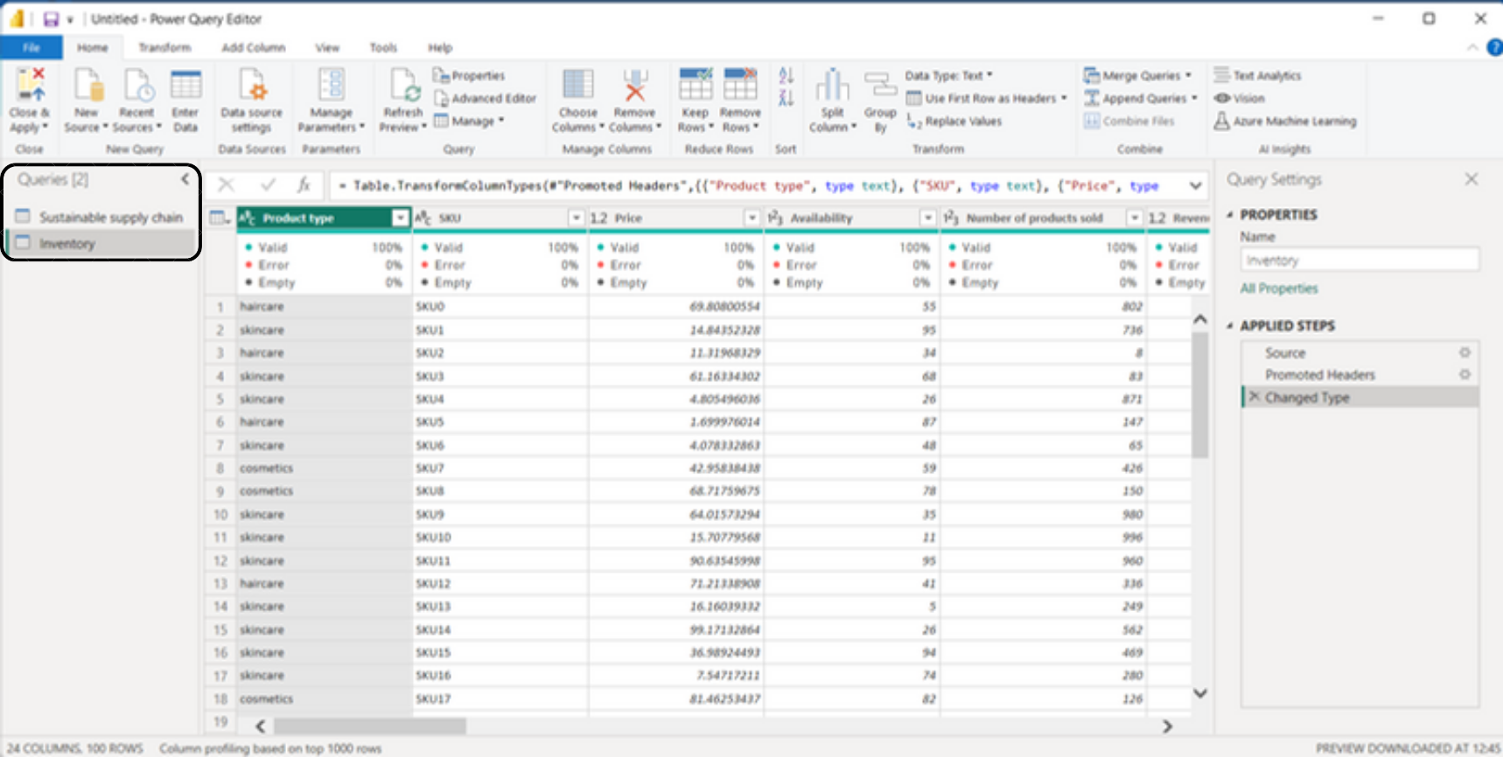

**Remove Unnecessary Columns:**

* Select the columns you don’t need by clicking on their headers.
* Right-click on the selected columns and choose **Remove Columns**

**Close & Apply:**

* + After completing the transformations, click **Close & Apply** in the top-left corner of the Power Query Editor to save changes

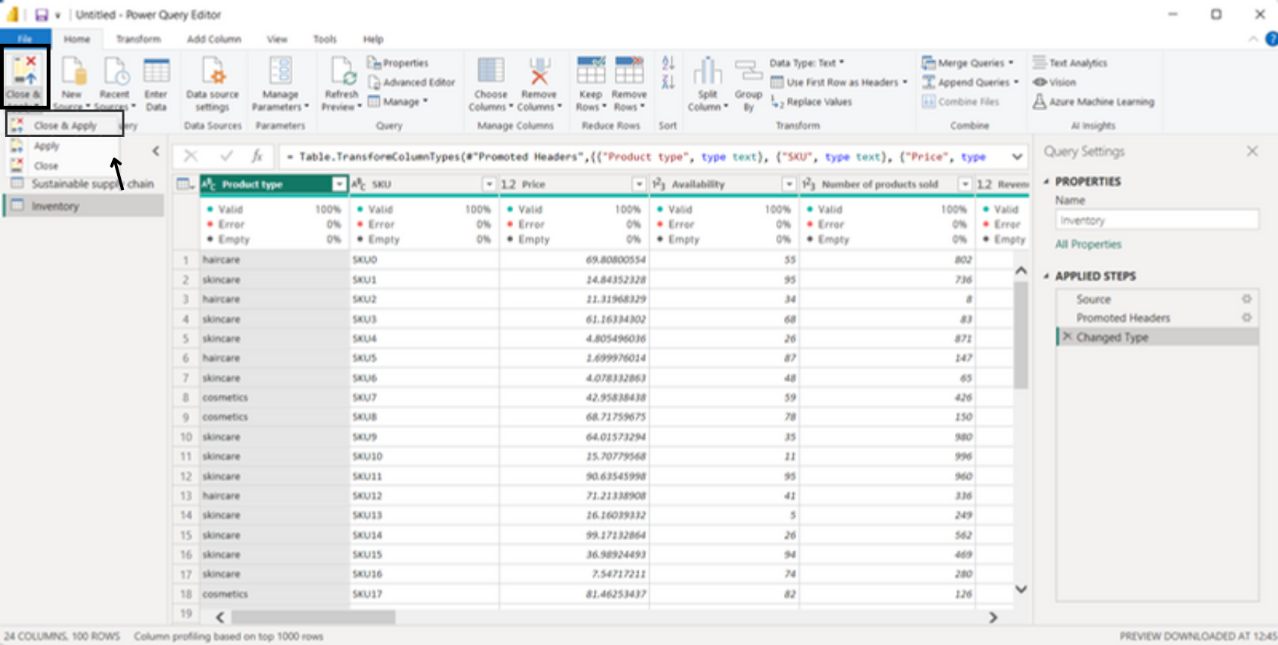

Finally, the dataset will appear on the **Home screen** in the **right-side corner** (Fields pane). Save the file to preserve your changes.